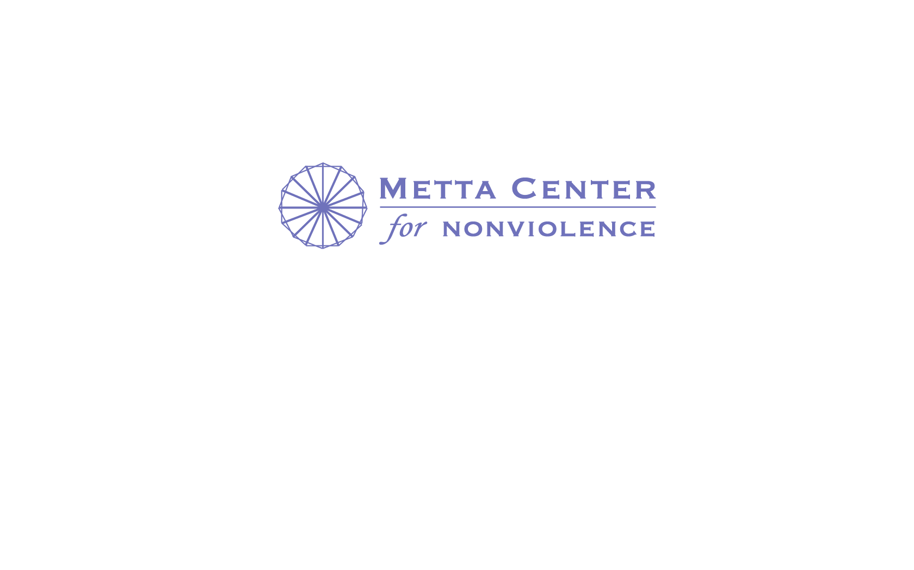

# Internship Opportunities at the Metta Center for Nonviolence

If internships or service learning are part of your semester requirements, or if you are simply looking for ways to put your learning into action, please consider the Metta Center for Nonviolence as a place where you can volunteer. We offer the unique opportunity to make meaningful contributions to the transition to a nonviolent future while expanding your own knowledge and understanding of nonviolence.

Internships can be conducted virtually (online) or on site at our office in Petaluma, and may include projects such as:

* Nonviolence research (including history, science of nonviolence, etc.)
* Creating additional [Peace Profiles](http://mettacenter.org/gender-eyes/peace-profiles-sojourner-truth/) for our series; involves research and writing
* Help develop nonviolence-related lesson plans and materials for educators - ideal for students in education programs!
* We are happy to tailor a project to match your needs with our own.

You can visit our [internships page](http://mettacenter.org/get-involved/jobs-and-internships/) to get additional ideas of how you may contribute.

The benefits that you may receive from this internship include:

* Feeling good about the impact you have made
* Finding a deeper purpose in your life
* Receiving training that can support you in future careers or service
* Meeting new people with diverse backgrounds and interests
* Exploring the nonviolent community through real life experience
* Obtaining valuable experience for your resume and recommendations from a respected organization
* Taking an active role in establishing a sense of community through meaningful work
* Other benefits include: gaining a base of support, team building, and becoming part of an in depth nonviolence definition that is unique to the field we are in.

Please contact [education@mettacenter.org](mailto:education@mettacenter.org) with any questions. We look forward to working with you!